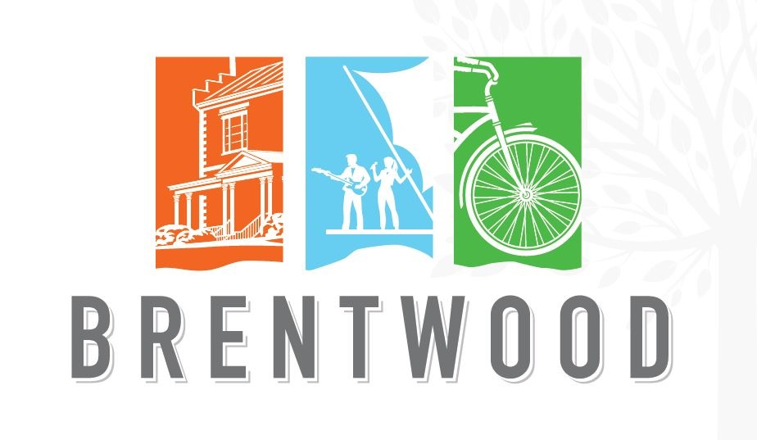
2025 Community Events
Friends Used Book Sale Jan. 30- Feb. 3 Brentwood Library
History Bowl Feb. 27 @ 7 p.m. Brentwood City Hall
Citizens Fire Academy Feb. 20-April 18 TBD
Citizens Police Academy March-May TBD Brentwood Police
Arbor Day March 29 Brentwood Library 10 a.m.-12:30 p.m.
Friends Used Book Sale April 11-13 Brentwood Library
Easter Egg Hunt April 19 @ 1pm Brentwood Library
Spring Cleanup Collection April 19 Granny White Park
Spring Cleanup Collection April 26 Tower Park
Spring Cleanup Collection May 3 Granny White Park

Brentwood Summer Concerts – Crockett Park
Monsters of Yacht June 8 6-8pm
Mustache the Band June 22 6-8pm
Brentfest featuring Rubiks Groove June 28 6-9pm
Red, White and Boom July 4 7 p.m.

Friends Used Book Sale July 18-20 Brentwood Library
Fall Cleanup Collection October 18 Granny White Park
Fall Cleanup Collection October 25 Tower Park
Fall Cleanup Collection November 1 Granny White Park
Friends Used Book Sale Oct. 17-19 Brentwood Library
Christmas Tree Lighting December 1 @ 5:30pm Brentwood Library
Morning with Santa December 6 @ 9am Brentwood Library
Neighborhood Luminaries December 13 @ 6pm Neighborhoods

